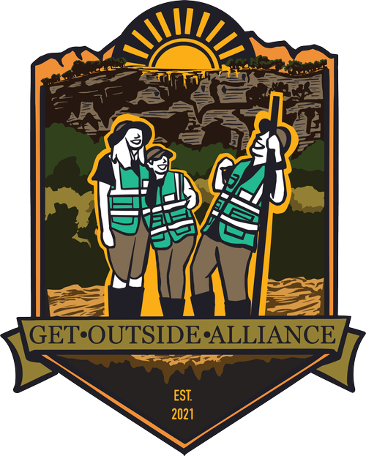

Get Outside Alliance Dashboard

User Manual

1. Getting Started:

Visit dashboard.getoutsidealliance.org. The dashboard is embedded within your domain so that it’s easier for everyone on your team to find. No login is required.

1. Choose a county to explore its demographic data:

Select counties for which you are interested in pulling demographic data

1. Understanding county demographic data:

When you select a county, the following information populates. You’ll see the number of parks, the name of the park, the average total population of the county, average adult population, how many schools are in the area, and how many students are enrolled in the school.

Students enrolled in school in the county and number of schools in the county

If relevant, parks in the selected county

1. Selecting multiple counties at once

If you would like to select more than one county, the information below will populate in the dashboard.

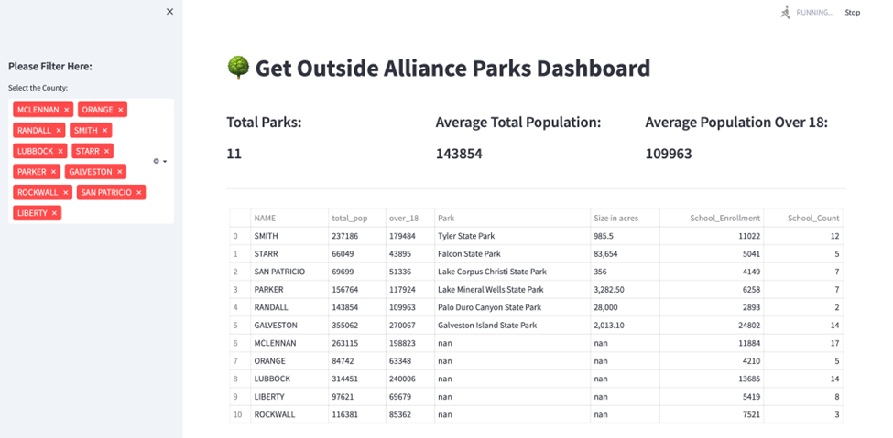

If there are no parks in the county, the parks column will return “Nan” or none available. All other information will be returned such as **total population, school enrollment** and **school count** in each county.

1. Understanding county map data

When multiple counties are selected, the relevant counties will highlight on the map and be color coated by the size of parks within the county. This helps users identify counties with the largest parks.

1. Closing the application

Simply close the browser page like you would any other web page. No data will be saved from your session.